Day 25 - 09th Aug 2025

Task01 Bridge Method Structural Design Pattern:

package BridgeMethod;

public interface ExcalidrawAPI {
void drawSquare(int s);
}
package BridgeMethod;

public class DrawingPicture implements ExcalidrawAPI {
@Override
public void drawSquare(int s) {
System.out.println("Draw square in Drawing Picture using Excalidraw with side " + s);
}
}
package BridgeMethod;

public class DrawingFrame implements ExcalidrawAPI {
@Override
public void drawSquare(int s) {
System.out.println("Draw square in Drawing Frame using Excalidraw with side " + s);
}
}
package BridgeMethod;

// Abstraction
abstract public class Shape {
protected ExcalidrawAPI excalidrawAPI;

protected Shape(ExcalidrawAPI excalidrawAPI) {
this.excalidrawAPI = excalidrawAPI;
}

abstract void draw();
}
package BridgeMethod;

public class Square extends Shape {
private int s;

Square(int s, ExcalidrawAPI excalidrawAPI) {
super(excalidrawAPI);
this.s = s;
}

@Override
void draw() {
excalidrawAPI.drawSquare(s);
}
}
package BridgeMethod;

public class Main {
public static void main(String[] args) {
System.out.println("Bridge Method Design Pattern - Structural DP!");

// Draw square using DrawingFrame
Shape square1 = new Square(5, new DrawingFrame());
square1.draw();

// Draw square using DrawingPicture
Shape square2 = new Square(10, new DrawingPicture());
square2.draw();
}
}
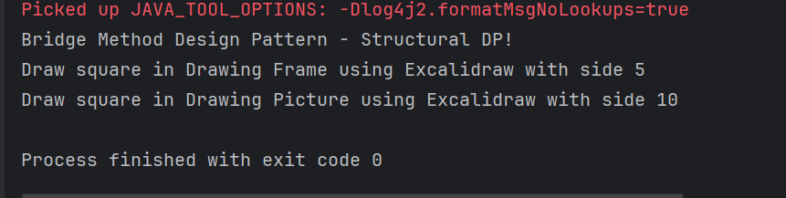

Task02 Composite Method Structural Design Pattern

package CompositeMethod;

// Base Component
public interface Company {
void displayName();
}
package CompositeMethod;

import java.util.ArrayList;
import java.util.List;

// Composite component
public class CompanyHead implements Company {
private int id;
private String name;
private List<Company> subDepartments;

public CompanyHead(int id, String name) {
this.id = id;
this.name = name;
this.subDepartments = new ArrayList<>();
}

@Override
public void displayName() {
System.out.println("Department: " + name);
subDepartments.forEach(Company::displayName);
}

public void addDepartment(Company company) {
subDepartments.add(company);
}

public void removeDepartment(Company company) {
subDepartments.remove(company);
}
}
package CompositeMethod;

public class HR implements Company {
private int id;
private String name;

public HR(int id, String name) {
this.id = id;
this.name = name;
}

@Override
public void displayName() {
System.out.println("HR Dept: " + name);
}
}
package CompositeMethod;
// Leaf component
public class Software implements Company {
private int id;
private String name;

public Software(int id, String name) {
this.id = id;
this.name = name;
}

@Override
public void displayName() {
System.out.println("Software Dept: " + name);
}

// Getters
public int getId() {
return id;
}

public String getName() {
return name;
}

// Setters
public void setId(int id) {
this.id = id;
}

public void setName(String name) {
this.name = name;
}

// Optional: for debugging
@Override
public String toString() {
return "Software{" +
"id=" + id +
", name='" + name + '\'' +
'}';
}
}
package CompositeMethod;

public class Main {
public static void main(String[] args) {
System.out.println("Composite Method DP - Structural DP");

// Create leaf departments
Company softwareCompany = new Software(1, "Software Development");
Company hrDepartment = new HR(2, "Human Resources");

// Create composite head
CompanyHead companyHead = new CompanyHead(3, "ABC Company");

// Add leaves to composite
companyHead.addDepartment(softwareCompany);
companyHead.addDepartment(hrDepartment);

// Display hierarchy
companyHead.displayName();
}
}
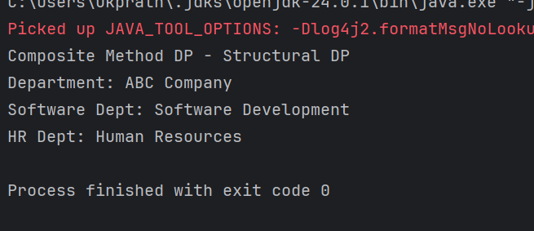

Task 03 Facade Method

package FacadeMethod;

public class BillingCounterService {
public void payBill(String accountId, String billId, double amount) {
System.out.println("paying for Mangoes "+ amount +"for billId "+ billId + "from account" +accountId);
}
}
package FacadeMethod;

public class MallFacade {
private StoreStaffService storeStaffService;
private BillingCounterService billingCounterService;

public MallFacade() {
this.storeStaffService = new StoreStaffService();
this.billingCounterService = new BillingCounterService();
}
public void getItems(String items) {
storeStaffService.getItems(items);
}
public void payBill(String accountId, String billId, double amount){
billingCounterService.payBill(accountId,billId, amount );
}
}
package FacadeMethod;

public class StoreStaffService {
public void getItems(String items) {
System.out.println("selecting Mangoes");
}
}
package FacadeMethod;

public class Main {
public static void main(String[] args) {
System.out.println("Facade Method DP - Structural Design Pattern");
MallFacade mallFacade = new MallFacade();
mallFacade.getItems("Fruits");
// mallFacade.transferMoney("123", "7777", 500.0);
mallFacade.payBill("123", "billno 44", 500.0);
}
}
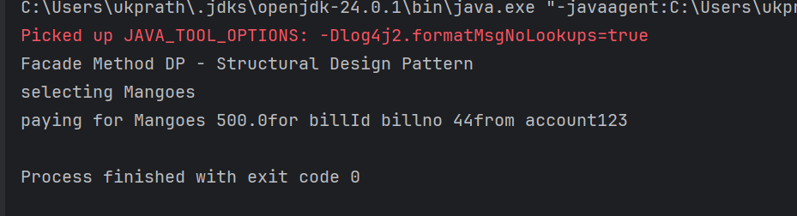

Task 04 Proxy design pattern

package ProxyMethod;

public class DataBase {
void execute(String Query, String desig) {
System.out.println("query execution is in process "+ Query);
}
}
package ProxyMethod;

public interface DatabaseExecute {
public abstract void executeQuery(String type);
}
package ProxyMethod;

import java.util.Objects;
public class ProxyDataBase implements DatabaseExecute{
String desig;
DataBase db;
public ProxyDataBase(String desig){
this.desig = desig;
db = new DataBase();
}
@Override
public void executeQuery(String Type){
if(Type.equals("Delete") && (!Objects.equals(this.desig, "ADMIN"))) {
System.out.println("you don't have permission to delete");
return;
}
db.execute(Type, this.desig);
}
}
package ProxyMethod;

public class Main {
public static void main(String[] args) {
System.out.println("Proxy Method Design Pattern - Structural design pattern");
DatabaseExecute emp1 = new ProxyDataBase("ADMIN");
emp1.executeQuery("Delete");
emp1.executeQuery("Write");
emp1.executeQuery("Read");

DatabaseExecute emp2 = new ProxyDataBase("HR");
emp2.executeQuery("Delete");
emp2.executeQuery("Write");
emp2.executeQuery("Read");

DatabaseExecute emp3 = new ProxyDataBase("EMPLOYEE");
emp3.executeQuery("Delete");
emp3.executeQuery("Write");
emp3.executeQuery("Read");
}
}
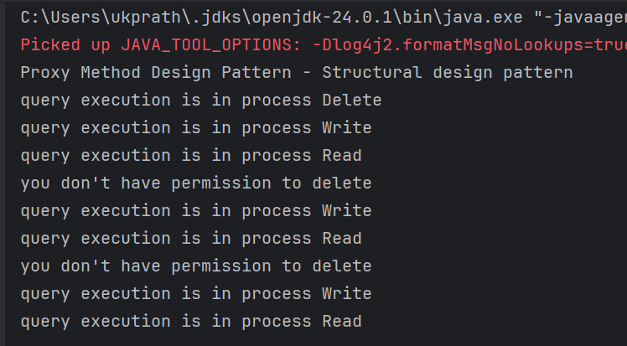

Task 05 Command Method Design Pattern

package BehavioralDP.CommandPattern;

public interface Command {
void doIt(); // executing a command
}
package BehavioralDP.CommandPattern;

public class DontDoTask implements Command {
private Task task;

public DontDoTask(Task task) { // ✅ Proper constructor
this.task = task;
}

@Override
public void doIt() {
this.task.dontTask();
}
}
package BehavioralDP.CommandPattern;

public class DoTask implements Command {
private Task task;

public DoTask(Task task) { // ✅ Proper constructor
this.task = task;
}

@Override
public void doIt() {
this.task.doTask();
}
}
package BehavioralDP.CommandPattern;

public class Mom {
private Command command;

public void setCommand(Command command) {
this.command = command;
}

public void executeCommand() {
this.command.doIt();
}
}
package BehavioralDP.CommandPattern;

public class Task {
public void doTask() {
System.out.println("do your home tasks");
}

public void dontTask() {
System.out.println("don't do your home tasks");
}
}
package BehavioralDP.CommandPattern;

public class Main {
public static void main(String[] args) {
System.out.println("Command Pattern - Behavioural DP");

Task task = new Task();
Mom remote = new Mom();

Command onCommand = new DoTask(task);
Command offCommand = new DontDoTask(task);

remote.setCommand(onCommand);
remote.executeCommand(); // "do your home tasks"

remote.setCommand(offCommand);
remote.executeCommand(); // "don't do your home tasks"
}
}
